**TYPE:** TEST



Southern River College

Year 11 Human Biology

Task 1: Test

2021

**TASK 1: Scientific Method and Cells Structure and Function Test (45 marks)**

Students will complete a number of questions relating to investigating scientifically. These questions will address the investigating process as well as analysis of second-hand data. This task will be completed in one session under test conditions.

**Time for the task (1 hour)**

* 5 minutes reading time
* 55 minutes working time

**What you need to do:**

* Follow the instructions provided very carefully to complete the test.
* Draw any results in pencil and answer all questions given.
* It is your responsibility to organise your time effectively.
* There is to be no discussion between you or any of your class mates.
* No sharing of any equipment or answers at all.

|  |  |
| --- | --- |
| **Requirements for assessment** | **Date:** |
| Complete all questions | _**__________________** |

|  |  |  |
| --- | --- | --- |
| Section | Marks available | Your Marks |
| A – Multiple Choice | 13 |  |
| B – Short Answer | 32 |  |
| Total | 45 | = % |

**DO NOT TURN THIS PAGE OVER UNTIL YOU ARE TOLD TO**

**STUDENT NAME: _______________________________________________________**

**YEAR: 11**

**TEACHER: Ms Burns**

**Scientific Method and Cells, Structure and Function Test**

**Section A - Multiple Choice**

**Instructions: Record the letter of your answer on the Multiple-Choice Answer Sheet provided.**

1. The basic structural unit units of life are:
   1. tissue
   2. organs
   3. systems
   4. cells
2. What is the name given to the variable that is measured in an investigation?
   1. dependent variable
   2. highly variable
   3. independent variable
   4. the measurement
3. The series of interconnecting canals that transport fluid through a cell are called:
   1. endoplasmic reticulum
   2. centrioles
   3. golgi bodies
   4. mitochondria
4. The mitochondria:
   1. give rise to the endoplasmic reticulum
   2. are usually doubled-layered organisms with finger like extensions
   3. are the centre of RNA synthesis
   4. are the centres of cellular respiration
5. Mammalian sperm cells expend a large amount of energy in moving through the female reproductive tract. On the basis of this information you would predict that these cells would contain a large number of:
   1. vacuoles
   2. mitochondria
   3. ribosomes
   4. chloroplasts
6. The organelles of the cell are concerned with essential processes, one of which is the synthesis of protein. This particular organelle is the:
   1. ribosome
   2. Golgi body
   3. nucleolus
   4. endoplasmic reticulum

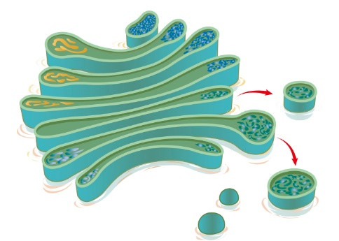

1. What is the structure shown in the picture?
   1. endoplasmic reticulum
   2. Golgi body
   3. vacuole
   4. lysosome
2. All cells obtain energy for their general metabolic activity by the oxidation of glucose. This basic process is known as cellular:
   1. reproduction
   2. respiration
   3. photosynthesis
   4. metabolism
3. Which of the following is not a good way to obtain valid results from an experiment?
   1. Use a large sample.
   2. Use a small sample
   3. Test a large population
   4. Repeat the experiment several times.
4. Scientific research must be conducted in an ethical manner. Which of the following statements identifies behaviour that would be classified as unethical?
   1. Informing participants that they are free to withdraw from the experiment whenever they wish
   2. Giving participants sufficient information, so they could give informed consent
   3. Making sure that the participants remain anonymous.
   4. Telling the participants that if they become part of the study that they must continue through to the end
5. A runner is on a training camp at the beach. The very first morning before breakfast, they go on a 9-kilometre run through the sand dunes. The runner covers the 9-kilometre trail in a time of 38 minutes. After a week of intense training, the runner can now do the trail in a time of 33 minutes. The percentage change for the athlete’s time was:
   1. 23.6%
   2. **-** 13.2%
   3. 0.132%
   4. 13.2%
6. A chemical was analysed and found to contain: 10% sodium, 30% potassium, 40% oxygen

15% magnesium and 5% other elements. The LEAST appropriate way to display this information is:

* 1. a table
  2. column graph
  3. pie chart
  4. line graph

1. Which of the following types of molecules are the major structural components of the cell membrane?
   1. phospholipids and cellulose
   2. nucleic acids and proteins
   3. phospholipids and proteins
   4. proteins and cellulose

.

**Section B – Short Answer**

**Instructions: Write your answers in the space provided in this booklet.**

1. A drug ‘LBP’, which is administered intravenously, increases the depth of breathing in patients suffering from asthma. In response to patients who dislike injections a new formulation of LBP has been developed which can be administered as an inhalant. Design an experiment (**by answering the following questions**) to test whether the new formulation is an effective treatment.
   1. State a suitable hypothesis (1 mark)
   2. What would be the independent variable? (1 mark)
   3. What would be the dependent variable? (1 mark)
   4. What treatment would your experimental group receive? (1 mark)
   5. What would a suitable control be? (1 mark)
   6. Why have a control group? (1 mark)
   7. What treatment would they receive? (1 mark)
   8. State at least four variables that need to be controlled. (2 marks)
   9. Explain how you could increase the reliability of your experiment. (1 mark)

**2.** The data presented in the table below was recorded during an experiment in which the experimenter varied the concentration of carbon dioxide (CO2) in the air breathed by the subject, to see what effect it would have on the subject’s breathing rate.

|  |  |
| --- | --- |
| **Percentage CO2** | **Breathing rate (breaths/minute)** |
| 1.0 | 14 |
| 1.5 | 15 |
| 2.0 | 15 |
| 3.0 | 15 |
| 5.5 | 16 |
| 6.0 | 27 |

(i) State a hypothesis which is being investigated in this experiment. (1 mark)

________________________________________________________________________________________

________________________________________________________________________________________

(ii) What is the independent variable? (1 mark)

________________________________________________________________________________________

________________________________________________________________________________________

(iii) What is the dependent variable? (1 mark)

________________________________________________________________________________________

________________________________________________________________________________________

1. Plot a line graph on the graph paper below to display the data in the table. (4 marks)
2. Would a prediction of the breathing rate at 4% carbon dioxide be likely to be more or less accurate than a prediction of breathing rate at 7% carbon dioxide? Explain your answer.

(2 marks)

________________________________________________________________________________________

________________________________________________________________________________________

________________________________________________________________________________________

________________________________________________________________________________________

________________________________________________________________________________________

________________________________________________________________________________________

1. What are **THREE** variables which would have been controlled in this experiment. Explain.

(3 marks)

________________________________________________________________________________________

________________________________________________________________________________________

________________________________________________________________________________________

________________________________________________________________________________________

________________________________________________________________________________________

_______________________________________________________________________________________

3. For the numbered parts of the animal cell diagram in the table which follows, name each part and describe its function. (10 marks)

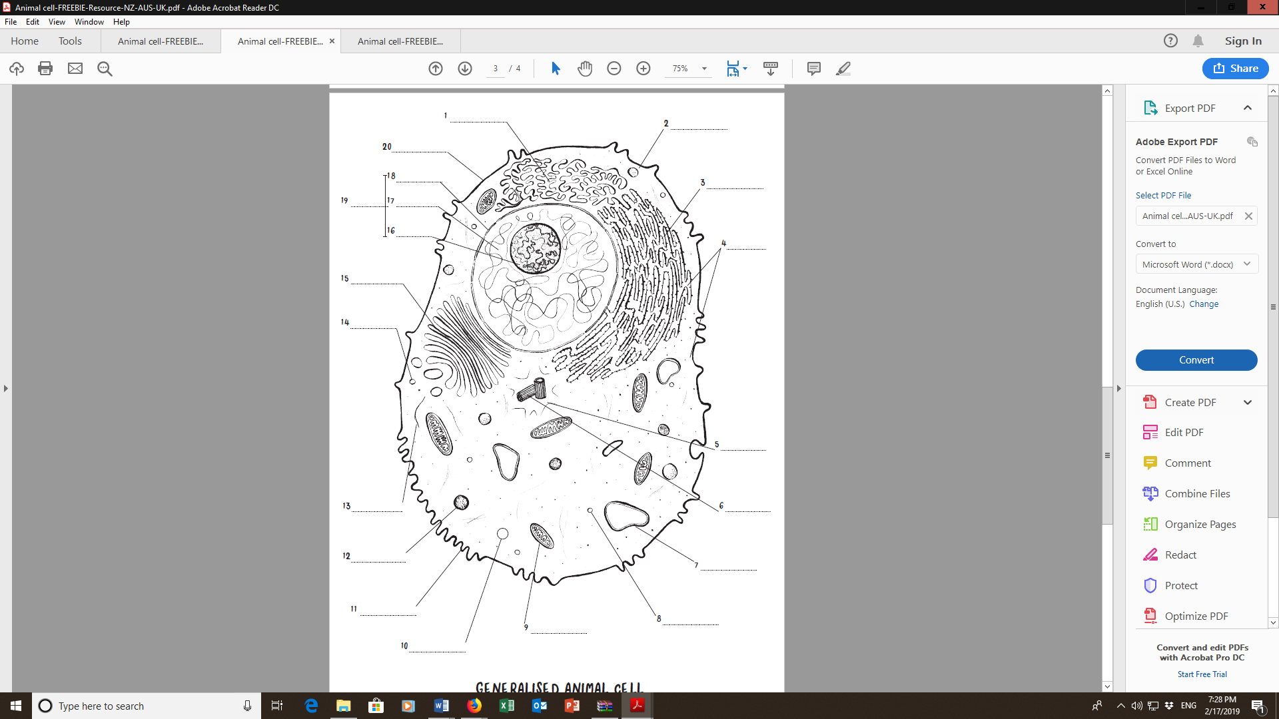

|  |  |  |
| --- | --- | --- |
| Numbered part | Name | Function. |
| 4 |  |  |
| 9 |  |  |
| 14 |  |  |
| 15 |  |  |
| 20 |  |  |
|  |  |  |

END OF TEST

SPARE GRAPH PAPER